Phase III: System Modeling and Prototype

Prepared by Elementary Engineers:

Olga Sheehan, Sara Hakkoum,

Eric Holm, Ethan Fiero

Instructor: Dr. Jung

Framingham State University

Spring 2016

## Abstract

The “Fraction Worksheet Creator” (FWC) is an off-line worksheet generation tool designed by Elementary Engineers to help elementary school teachers to create a lot of exercises for students to study and practice fractions. The fractions worksheets are randomly created and never repeated so the teachers have an endless supply of quality fractions worksheets to use in the classroom or at home.

The purpose of this document is to explain the designed system model using class diagram for the “Fraction Worksheet Creator” (FWC) software for the user. It will illustrate the partial prototype version and demonstrate the features of the software.

This document is primarily intended to be proposed to a customer and the board of directors for their approval and a reference for developing the first version of the system for the development team.

Table of Contents

Abstract 1

Overview 2

User 2

EncryptedPassword 2

Relationship Class Diagram 3

Teacher/User Login Profile Graphical Prototype 3

Admin 4

Teacher 4

Student 5

Relationship Class Diagram 5

Class 6

Worksheet 6

Difficulty 7

Relationship Class Diagram 7

Teacher Home Page Graphical Prototype 8

FractionGenerator (FNG) 8

Equation 9

Fraction 10

WS_Master 10

Relationship Class Diagram 13

Worksheets Graphical Prototype 14

## Overview

### User

Represents all common information between all user’s accounts. Users only have one username, first name, last name and an encrypted password. A user can update their username, first name, last name and their password in the database. The user contains the reset password option.

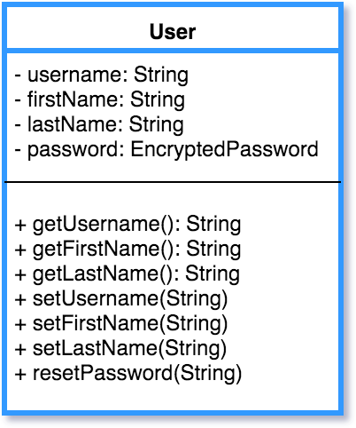

### EncryptedPassword

Rather than store Users’ passwords as cleartext, we use EncryptedPasswords to store each password securely. Passwords are hashed using a salt, and the hash and salt are stored in EncryptedPassword. All Users have an EncryptedPassword. When a User logs in, the password entered is checked against that User’s EncryptedPassword using checkPassword(String).

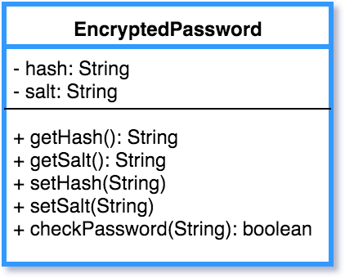

## Relationship Class Diagram

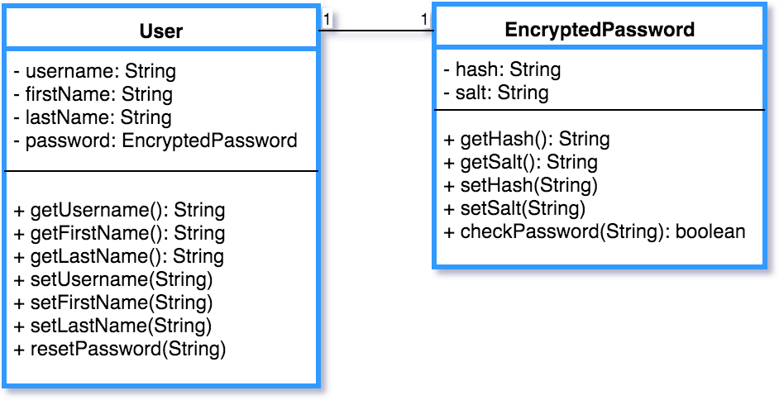

## Teacher/User Login Profile Graphical Prototype

### 

### Admin

Represents the information the Admin would have for their account. Admin will have and Array List of (Teachers and other Admins). They will also save their last 4 of their SSN, Birthday and First Job. These three fields will be used for the admin to reset their passwords; they will also be stored hashed. The admin can search through a list of teachers and admins. The admin can delete teachers and other admins and will update the database.

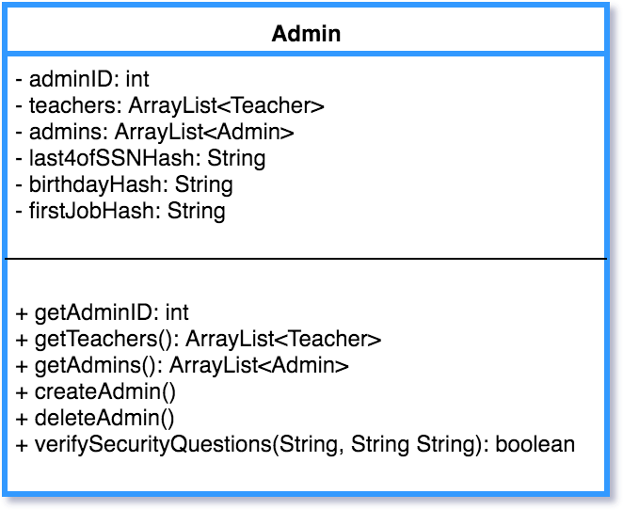

### Teacher

Represents the information the teacher would have for their account. Teachers will have a teacher ID, along with three Array Lists (Classes, History of Worksheets). A teacher can search for a particular class and history of worksheets. A teacher will be allowed to create and delete classes and this will be updated in the database. The teacher can set the min and max of (numerator and denominator).

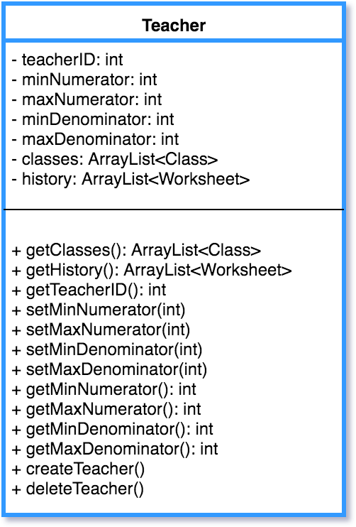

### Student

Represents the information the Student would have for their account. Student will be able see their history, difficultly level and class they are currently enrolled in. The Student will be able to search through their history of worksheets.

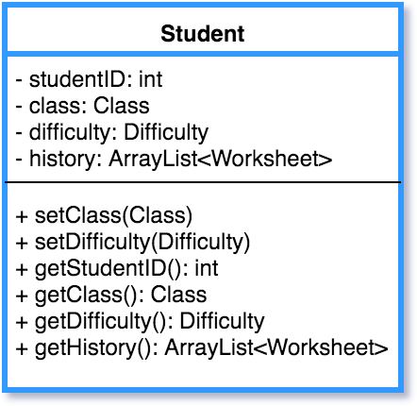

## Relationship Class Diagram

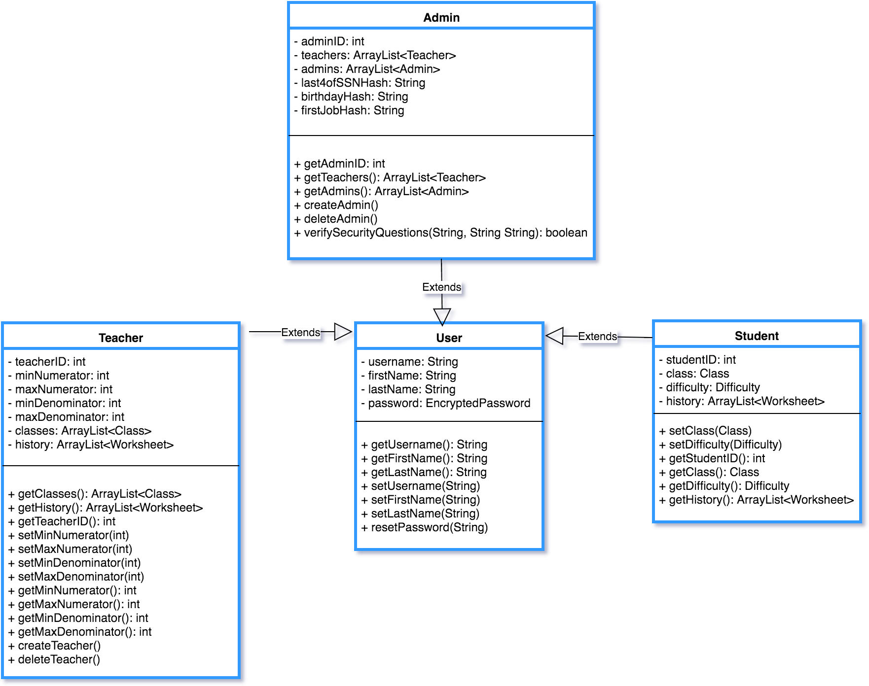

### Class

Represents a Class that a Teacher creates to add Students to. Classes have only one Teacher. A Teacher can create, edit, and delete Classes. setClassName(String) can be used to edit a Class’ name, and the updated Class object can be used to update that Class in the database.

Students can be added to and removed from a Class. A Class can be searched for a particular Student.

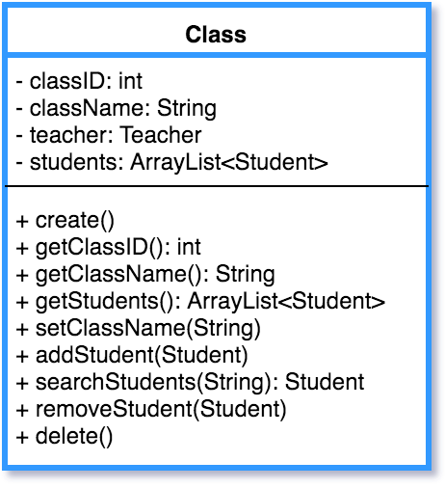

### Worksheet

A Teacher or a Student creates a Worksheet. When a Worksheet of any type is generated, a Worksheet object is used to represent it. Worksheet contains the information needed to recreate any Worksheet a Teacher or Student has created in the past. Deleting a Worksheet deletes that Worksheet from the corresponding User’s history.

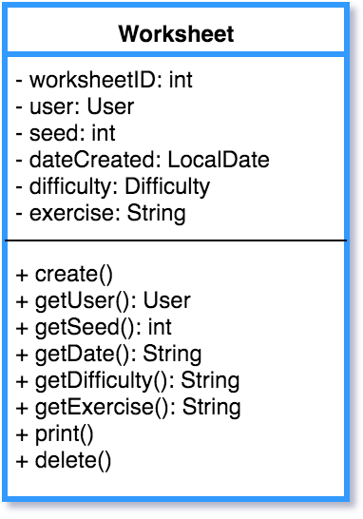

### Difficulty

Represents a difficulty level. There are 3 fixed Difficulties in the database: Beginner, Intermediate and Advanced. A Teacher assigns a Difficulty to a Student. Each Student has a Difficulty. A Student’s Difficulty can be changed using setDifficultyID(int) and using that Difficulty Object to update the database.

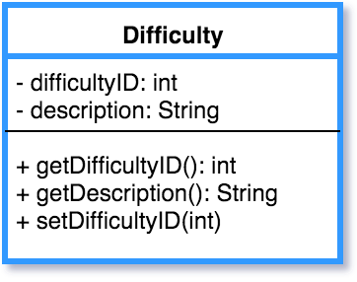

## Relationship Class Diagram

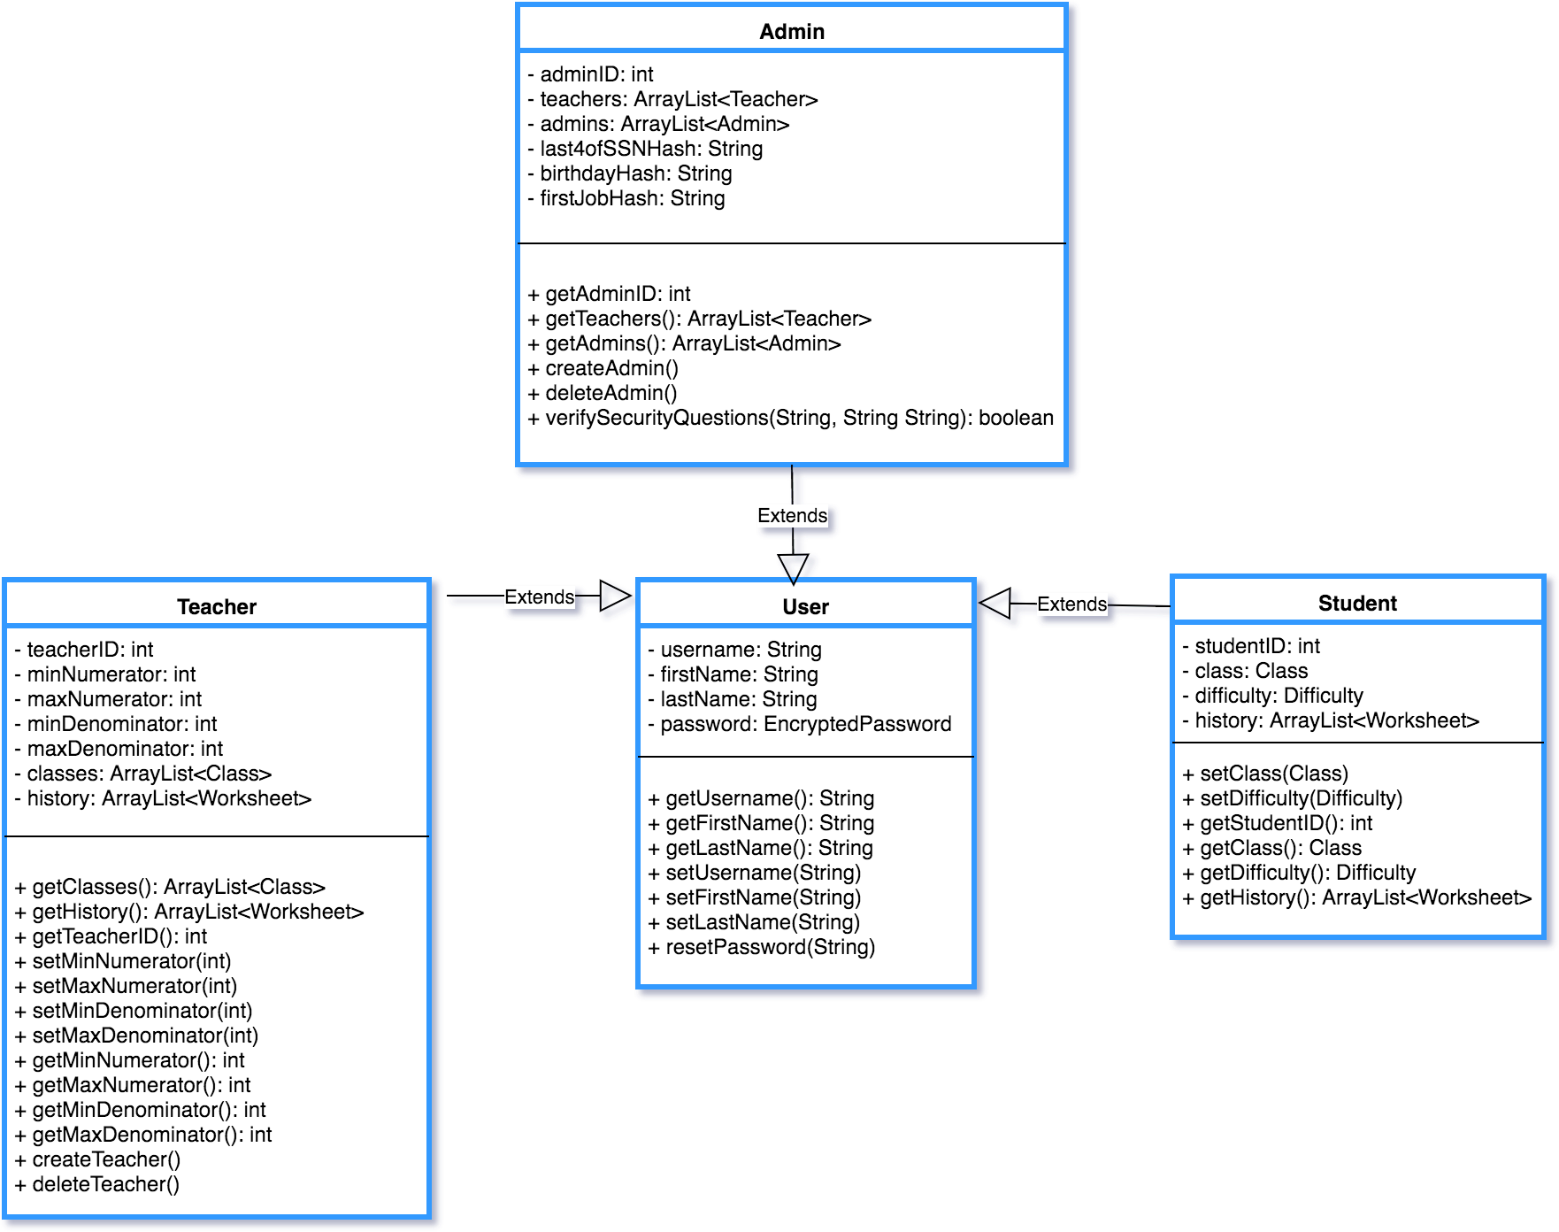

## Teacher Home Page Graphical Prototype

This is a sample of what the finished user/teacher interface may look like after including

graphical components.

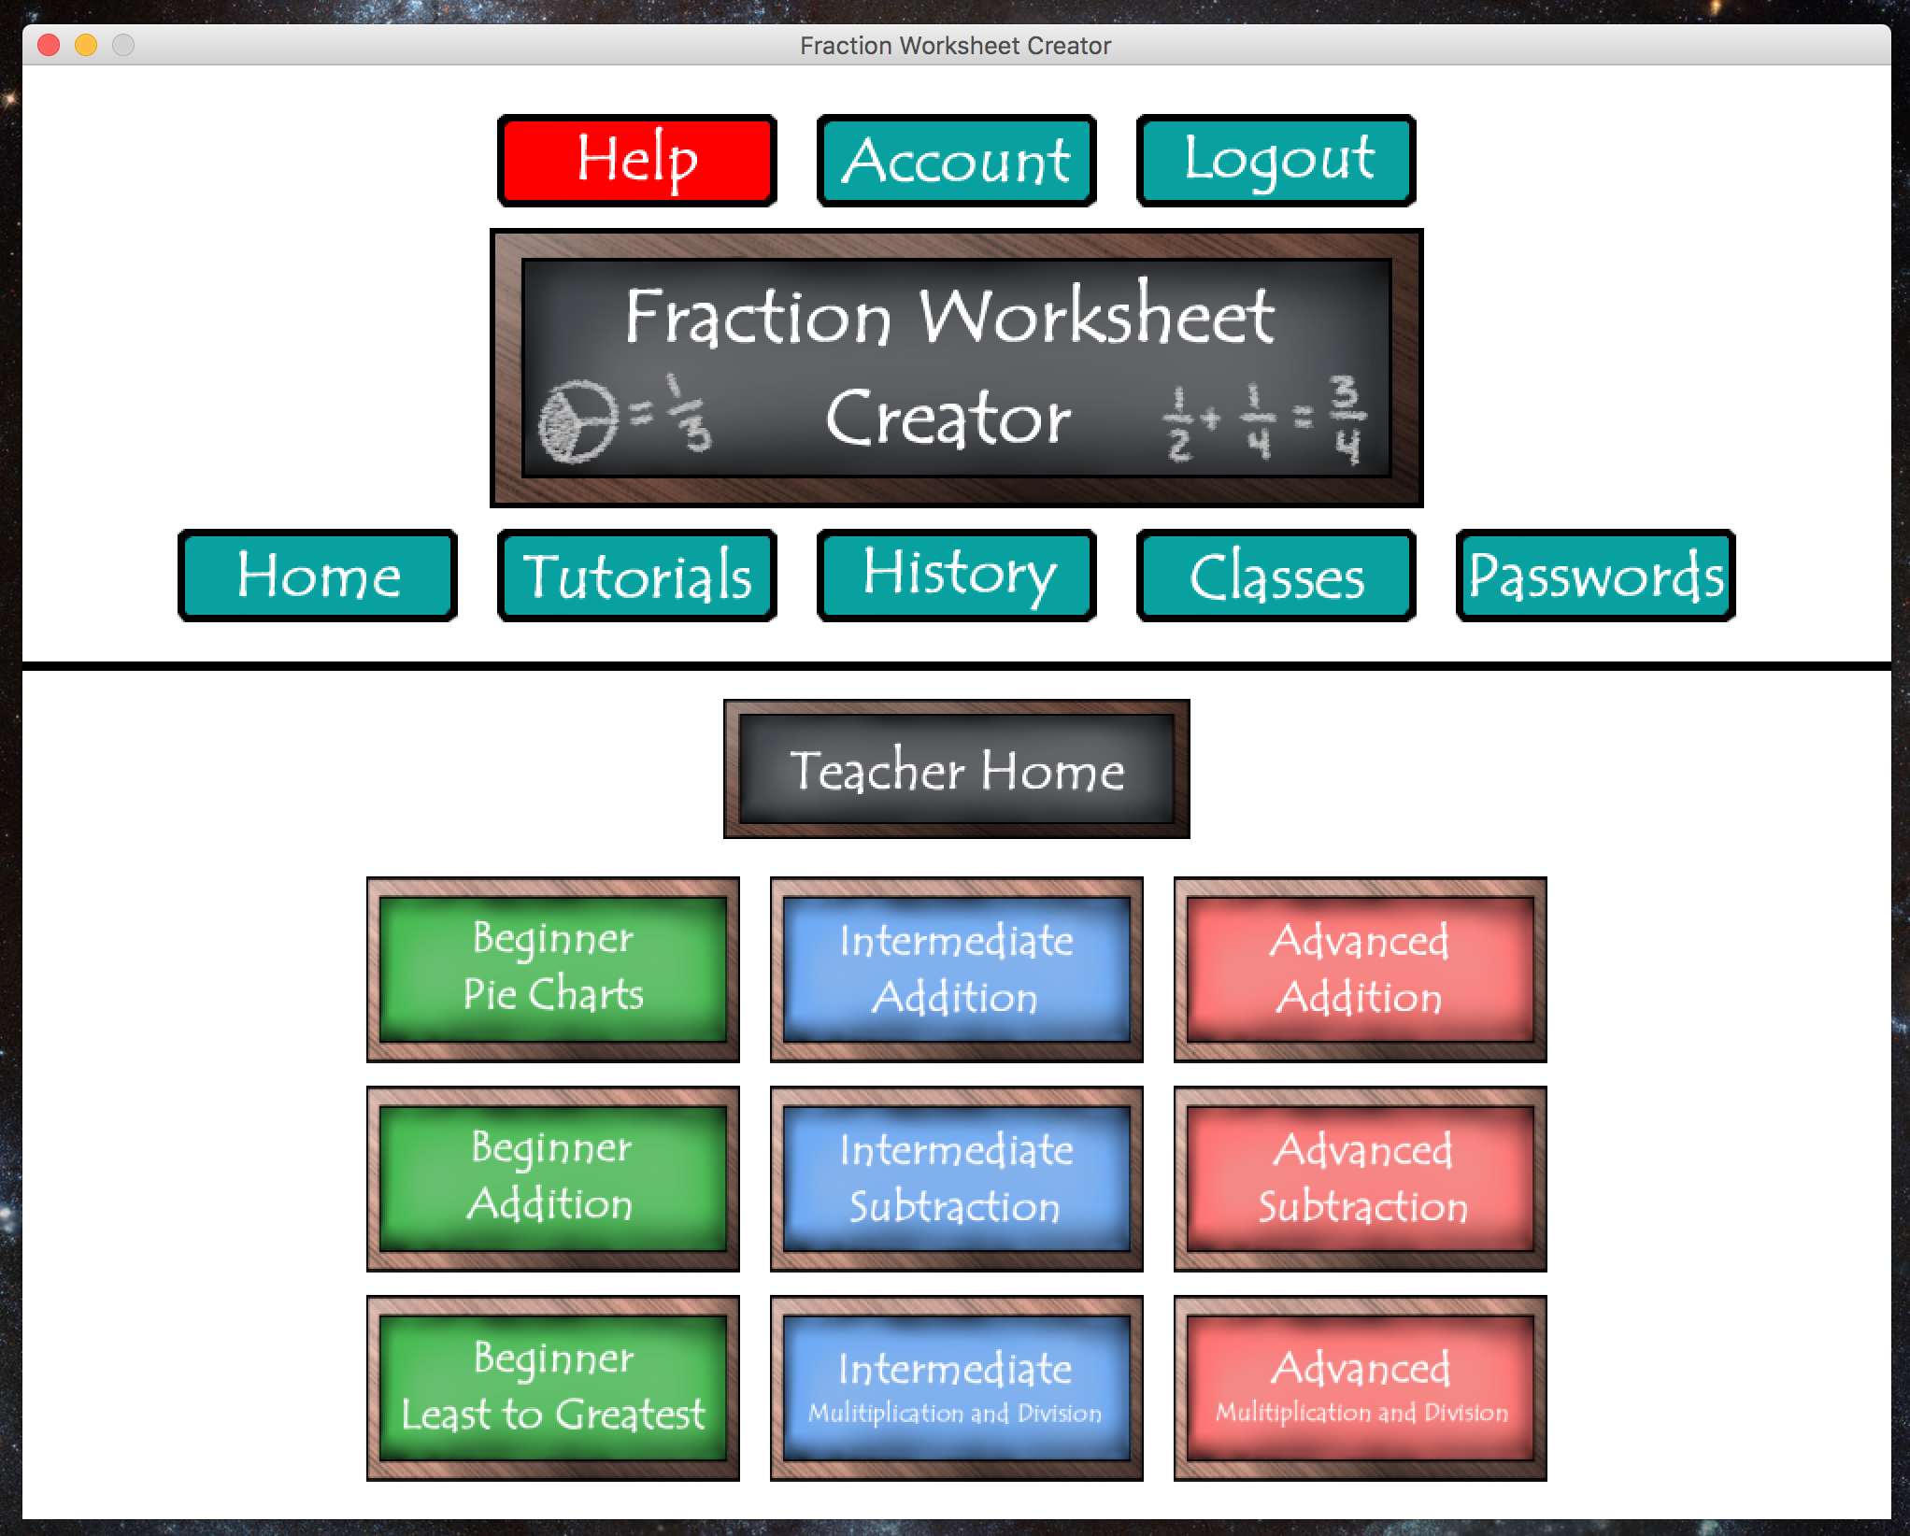

The **random** package of the Fraction Worksheet Creator is heart of programs , primary function of creating worksheets. There are multiple classes that build off one another to accomplish the task of generating the PDF files for the worksheets and answer sheets.

### FractionGenerator (FNG)

Generates a random set of fractions based on the parameters provided. This includes limits on the numerator, denominator, if whole numbers can be generated, and if matching denominators are required. Passes the fractions to calling classes as a List.

Equation

Forms equations based on the fractions generated by the FNG. Then based on the operator for this equation it calculates the answer, which is stored in an additional Fraction class object.

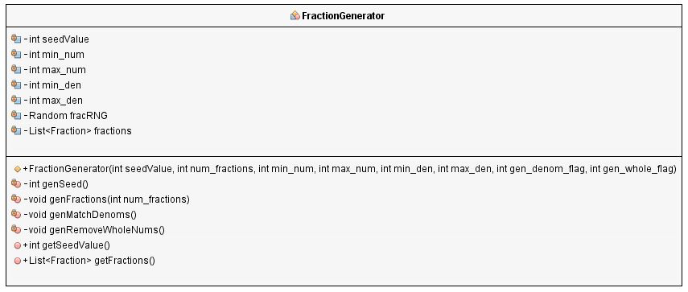

### Equation

Forms equations based on the fractions generated by the FNG. Then based on the operator for this equation it calculates the answer which is stored in an additional Fraction class object.

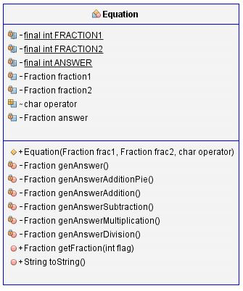

### Fraction

The base class for describing a fraction. Includes the numerator and denominator and provides the ability to reduce fractions to their lowest terms.

## 

### WS_Master

An abstract class used to store common data for all worksheets. This includes the list of fractions generated by the FNG, the seed value used to create the fractions and the base worksheet document. This includes common header and footer methods for all worksheets. Example and Problem methods must be implemented by all subclasses.

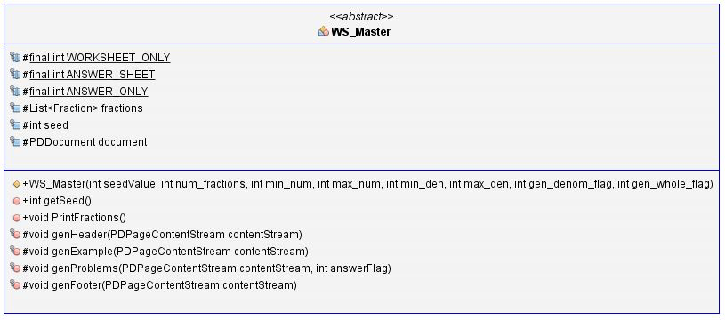

The following subclasses use WS_Master

WS_Beginner_LG – Beginner Least to Greatest problems

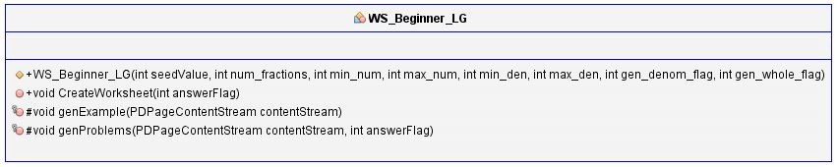

WS_Beginner_Pie – Beginner pie diagram to fraction problems

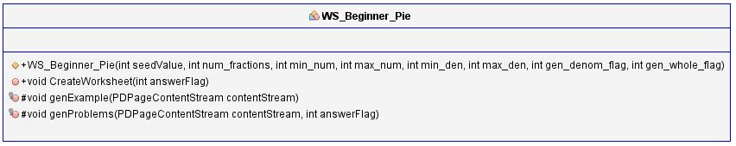

WS_Beginner_PieAdd – Beginner pie diagram addition problems

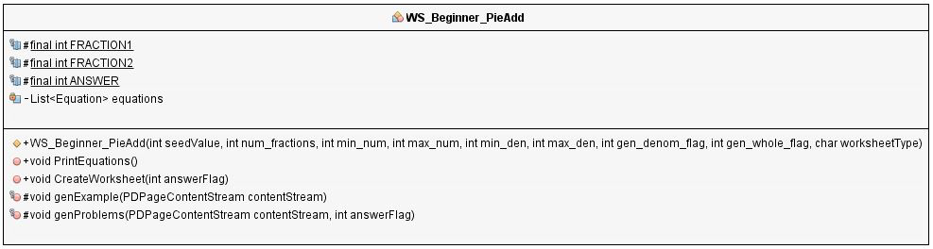

Beginner worksheets require separate subclasses since there is little commonality between the different worksheets at this level.

WS_Intermediate – All three intermediate worksheets (Addition, Subtraction, Multiplication/Division) use this one subclass since the only differentiator is the operator. The equation class handles the answers being different based on the operator used for the sheet.

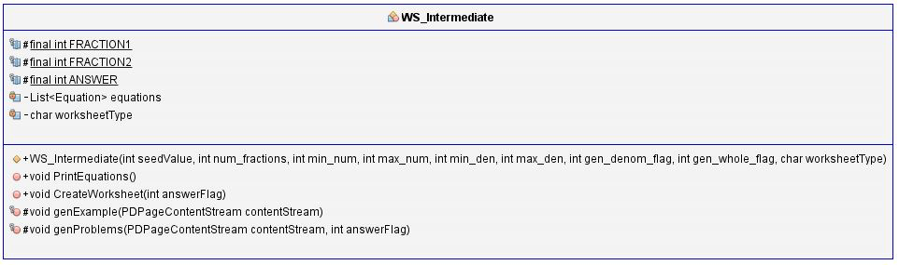

WS_Advanced – All three advanced worksheets (Addition, Subtraction, Multiplication/Division) use this one subclass since the only differentiator is the operator. The equation class handles the answers being different based on the operator used for the sheet.

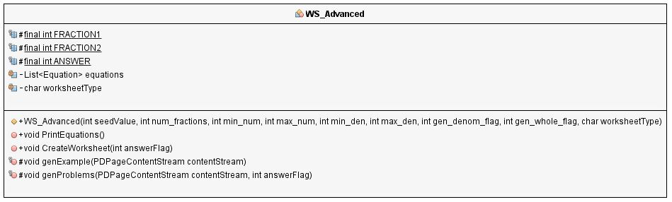

## Relationship Class Diagram

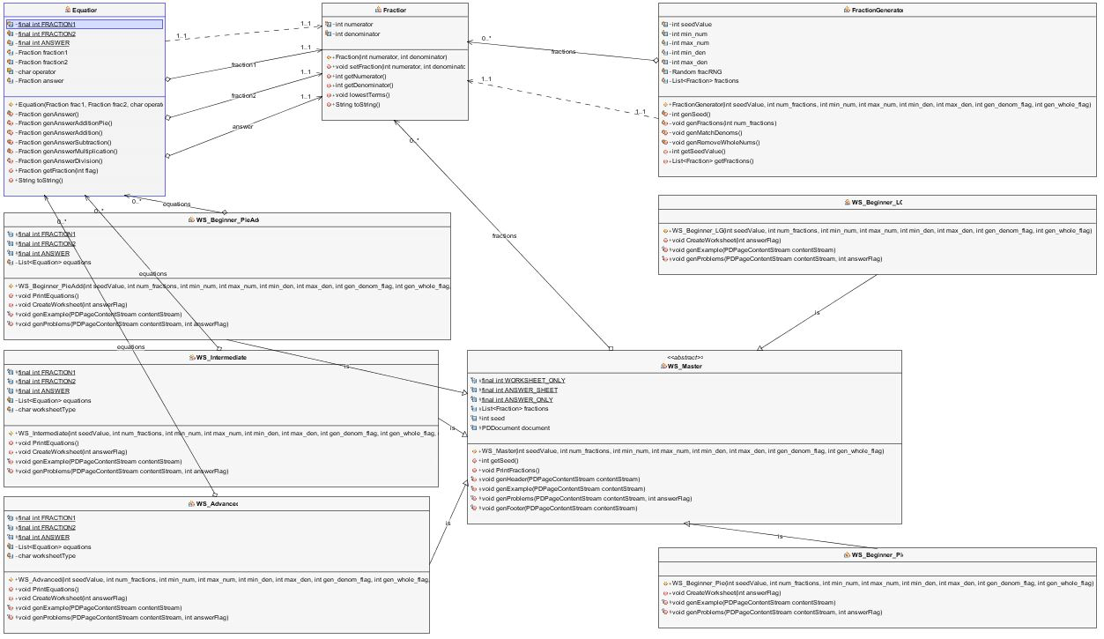

## Worksheets Graphical Prototype

This is a sample of what the finished samples of worksheets may look like .

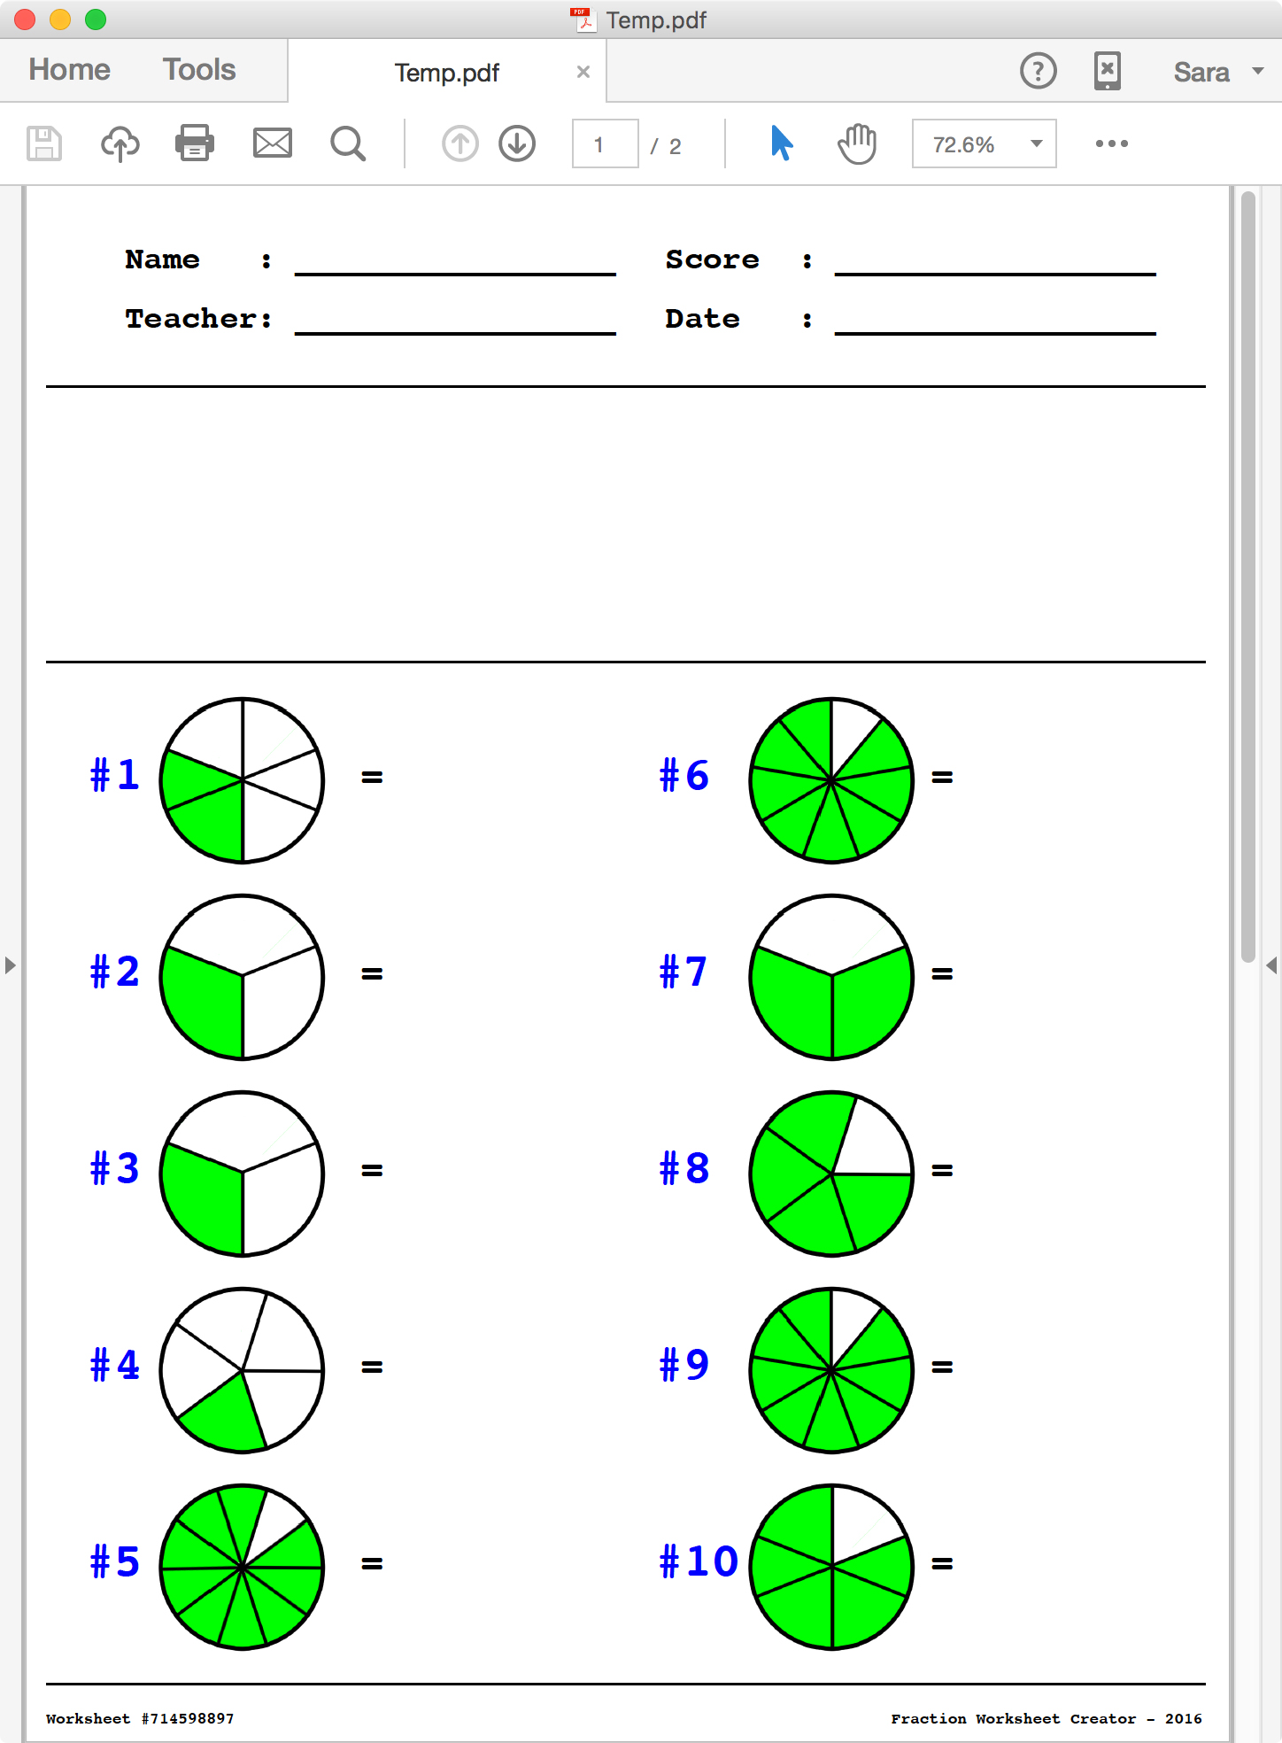

This is a sample of what the finished samples of the answer worksheet may look like .

